Vocabulary
Country | A large area of land where people live under the same government or have the same culture.
Continent | One of the earth's seven major areas of land. The continents are Africa, Antarctica, Asia, Australia, Europe, North America, and South America.
UK | Country comprised of 4 nations – England, Northern Ireland, Scotland and Wales
Equator | The imaginary line around the earth’s surface equidistant from the north and south pole
Human features | Features of the landscape that are man made.
Natural features | Features of the land scape that are natural.
City | A place in Britain that has received the title from the crown
Town | A built up area that is larger than a village and smaller than a city
Village | A small group of houses in a country area, usually larger than a hamlet
Hamlet | A small settlement smaller than a village and strictly without a church
Urban | A built up area such as a town or a city
Rural | A countryside area
Local | The area close by
Agriculture | Land used for producing crops and feeding, breeding and raising livestock
Arable farm | Land used for growing crops
Business | Buying and selling goods
Shop | A place where goods and services are sold
Office | A room or a building being used for business
Dairy farm | Land used for rearing cows to produce milk
Industry | Processing raw materials and make them into goods
Development | To grow and change, usually for the better
Factory | A building or group of buildings containing a plant assembly for the manufacture of goods.
Farm | An area of land used to grow crops or animals
High Street | Main street of a town containing shops, banks and other important businesses
House | A building for humans to live in
Semi-detached | A house joined to another by a shared wall
Detached house | A house that stands alone
Terraced | A row of houses joined together
Flats | A large building divided into separate living areas
On the Move
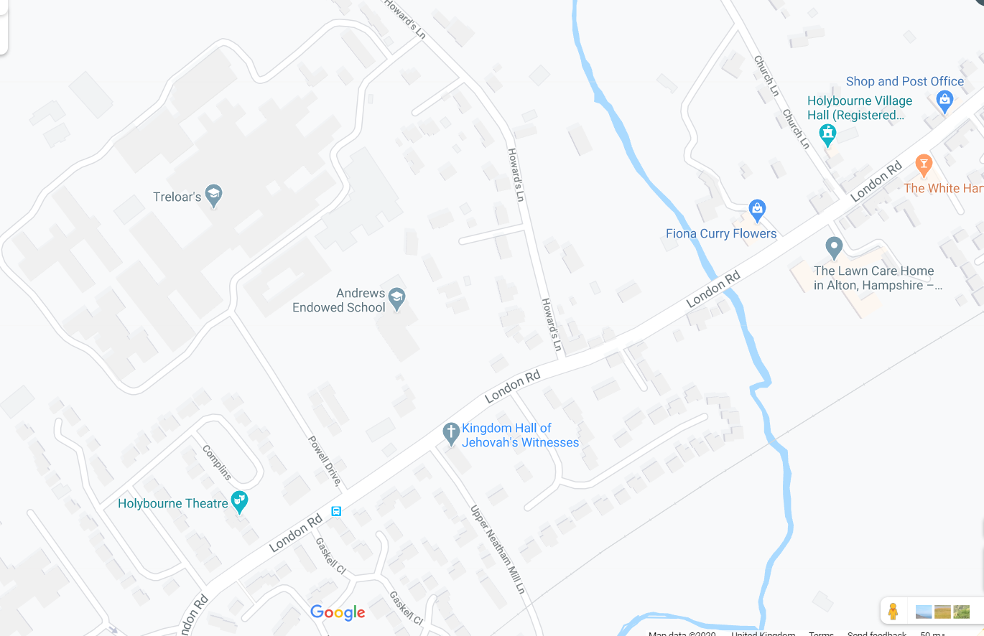

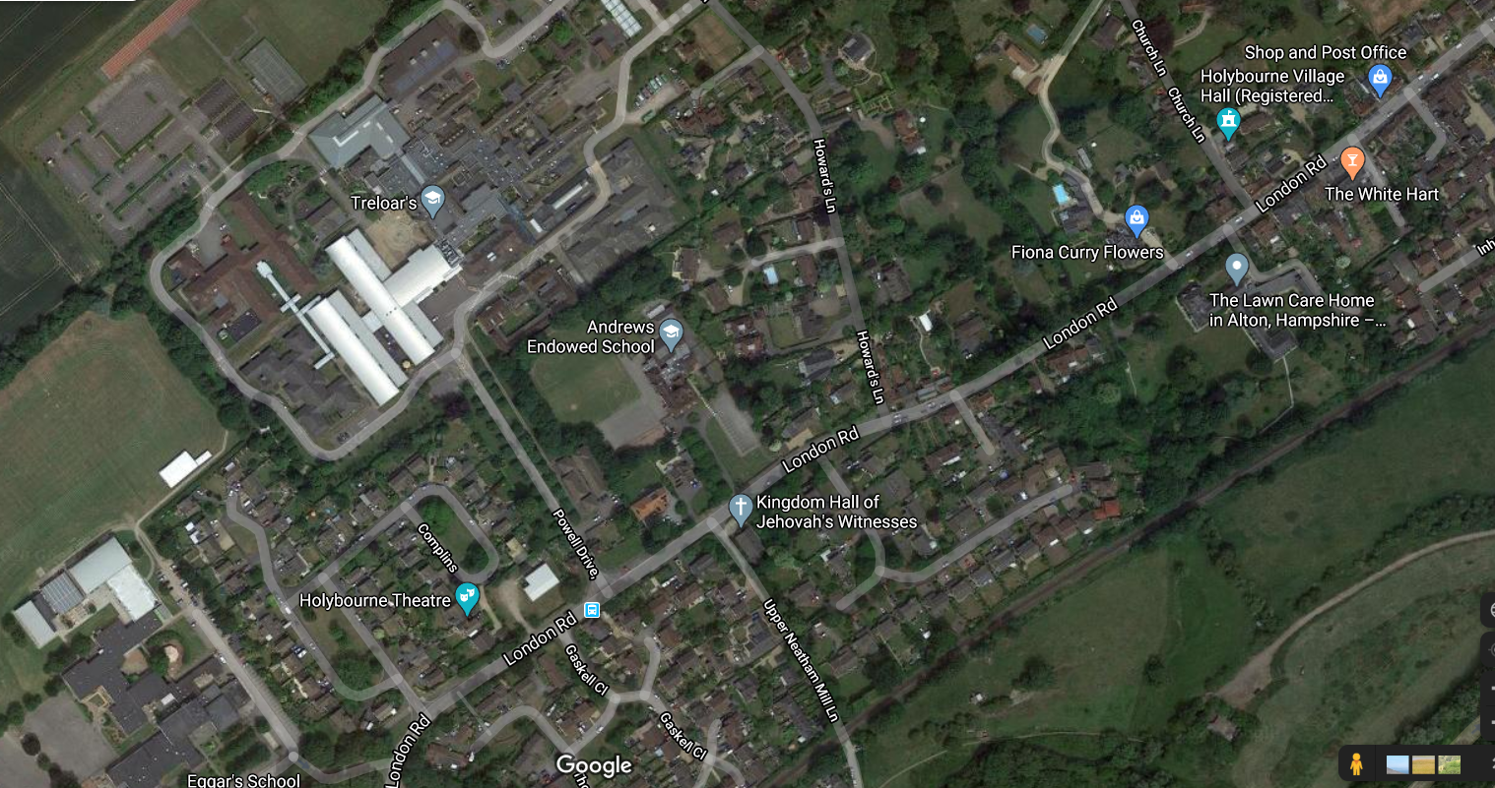
Facts
- Atlases, maps and satellite navigation can help us find our way around.
- We can plan routes using maps at different scales.
- We can explore and compare human settlements using maps and GIS (Geographic Information Systems)
- Geographical features are important when deciding the location of a facility (such as a school)
- Maps and plans use symbols and these can be interpreted using a key.

