Physical Geography
Climate zones  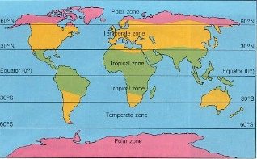 | Earth has three main climate zones - tropical, temperate, and polar. These zones can be further divided into smaller zones, each with its own typical climate. A region's climate, together with its physical characteristics, determines its plant and animal life.
Earthquakes  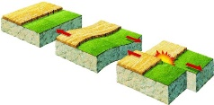 | An earthquake is the shaking of the surface of the Earth, resulting from the sudden release of energy in the Earth's lithosphere that creates seismic waves.
Mountains  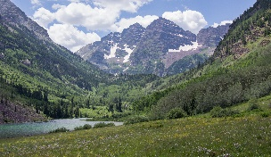 | A mountain is a large landform that rises above the surrounding land in a limited area, usually in the form of a peak. A mountain is generally steeper than a hill. Mountains are formed through tectonic forces or volcanism.
Tsunamis  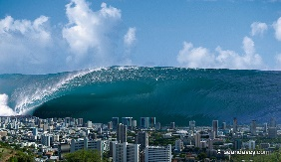 | A tsunami or tidal wave is a series of waves in a water body caused by the displacement of a large volume of water, generally in an ocean or a large lake.
Volcanoes 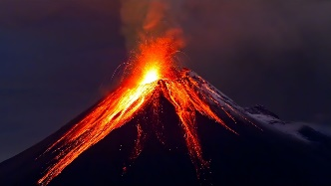 | A volcano is a rupture in the crust of a planetary-mass object, such as Earth, that allows hot lava, volcanic ash, and gases to escape from a magma chamber below the surface
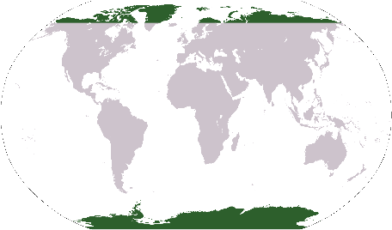
Extreme Earth
Fact Box
In 2012, the ash from a volcanic eruption in Iceland stopped planes from flying over Europe for a week!
Arctic Circle

Key Vocabulary
active | Working.
blizzard | Blinding storm of wind and snow.
cyclone | Violent wind moving clockwise round a central area.
dormant | Inactive.
drought | Prolonged shortage of rainfall.
earthquake | Violent vibration of the earth’s surface.
eruption | Eject violently.
hurricane | Very strong, often destructive wind or storm.
lava | Molten rock thrown out of volcanoes, which hardens as it cools.
magma | Molten rock inside the earth’s crust.
tectonic plate | Pieces of the earth’s crust.
tornado | Violent whirlwind.
tsunami | Tidal wave.
typhoon | Violent tropical storm.
volcano | Mountain with a vent through which lava is ejected.
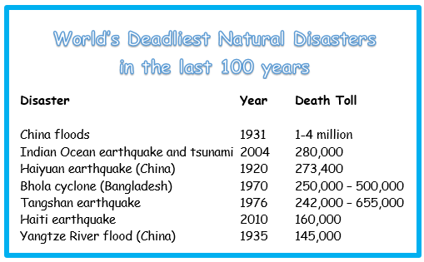
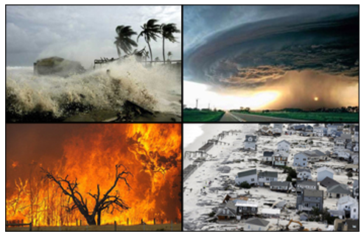
Fact box
A tsunami can travel at up to 600 miles in an hour! That’s as fast as a jet plane!
Natural disasters
A natural disaster is an event caused by nature such as floods, volcanic eruptions, tropical storms, tornadoes, landslides, wildfires and many more. These events cause great financial hardship for the people and communities in locations where they occur, and they can sometimes even result in loss of life.
Fact box

The word volcano comes from the name Vulcan, the Roman god of fire,
Fact box

In ancient Greece, people believed that the god of the sea, Poseidon, caused earthquakes. When he was angry, Poseidon would strike the ground with his trident and set off an earthquake. His unpredictable, violent behaviour earned him the nickname “Earth-Shaker”.
Antarctica

