Year 3 visited Butser Ancient Farm as part of their topic about the Stone Age. It is a unique experimental archaeology site nestled into the rolling countryside of the South Downs National Park.
The Farm features archaeological reconstructions of ancient buildings from the Stone Age, Iron Age, Roman Britain and the Anglo-Saxon period.
The children have the chance to experience Stone Age life through workshops.
This website lets you see some of the things for yourself.
https://www.butserancientfarm.co.uk/butser-plus
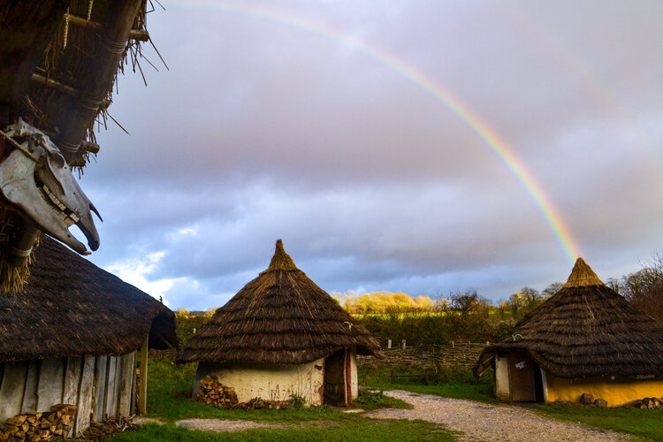
This is the children’s view of their trip –
It was a super trip because we got to make reed fences. They really worked as fences.
I enjoyed this trip because we weren’t just looking we made things all through the day. I made a cup out of dough.
One of the things I got to do was to see a copper ring being made and hear all about the Stone Age times. It was like being there.
I liked this trip as you got watch the people making things.
This trip was lots of fun!

