Summer 2022 OUTLINE OF WORK YEAR 3

ENGLISH  - Plan, draft and write using a variety of forms.  - Proofread for spelling and punctuation errors.  - Stories based on a book: imaginary worlds and historical fiction - varied sentence structure, dialogue and awareness of audience.  - Reports and newspapers: Identifying key features, locating information, making notes, sequencing and presenting in a recognised format, using paragraphs.  - Grammar: Use and understand grammatical terminology such as conjunction, adverbial, commas, apostrophes and inverted comma.  - Spelling: learning keywords and developing a range of different strategies for spelling.  - Handwriting: developing accuracy, fluency and spacing between and within words. |  | MATHEMATICS  - Fractions  - Time  - Geometry  - Measurement – mass and capacity  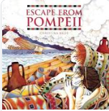  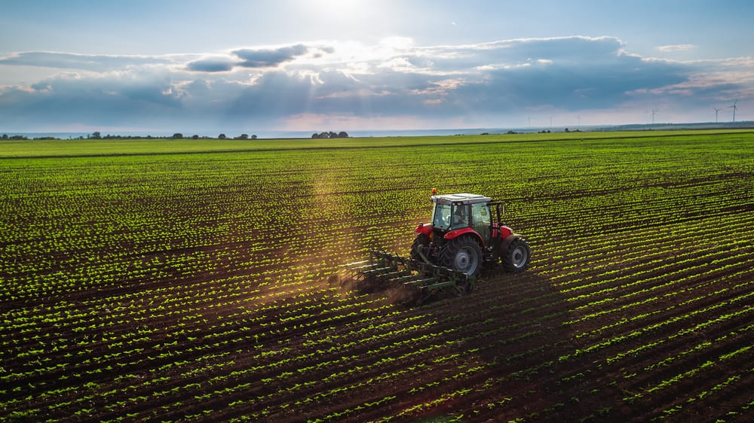 |  | PSHE & CITIZENSHIP:  - Healthy lifestyles  - What jobs would we like and what skills will we need?  PE:  - Athletics  GAMES  - Tennis, Rounders  MUSIC  - Exploring ostinato patterns using pitched and percussion instruments  - Listening to music from the past. E.g: Carillon from L’Arlésienne by Bizet and the medieval O Beata Infantia  DT  - Cooking  - Construction – Roman engineers  FRENCH  - Giving the date with days, months and years  - Saying our birthdays  SPECIAL EXPERIENCES  - Hampshire Farms visit  - Fishbourne Roman Palace Visit
COMPUTING  - Using the internet for research  - Google Docs  - Coding – algorithms: events and conditionals | HISTORY  Romans  - Caesar – to invade Britain or not to invade?  - Boudica – should she rebel?  - Roman towns – team spying activity  - Evaluating factors that helped the Romans control their empire  - Romans leaving Britain/ legacy |  | GEOGRAPHY  - Where does our food come from?  - Locating countries using an atlas – equator, tropics of Cancer and Capricorn, latitude and longitude.  - Contrasting farms in different areas of the UK  - Starting to think about climate zones and biomes
SCIENCE  - Healthy eating, healthy heart.  - Magnets | ART  - Natural outdoor art – Andy Goldsworthy  - Still life in the style of Cezanne – drawing and oil pastels  - Aboriginal dreamtime art  - Mosaics |  | R.E.  - Hindu Rituals – Learning about the Sacred Thread ceremony and the value of rituals  - People of God – Exploring the Christian and Jewish idea of covenant through the story of Noah

