AUTUMN 2020 OUTLINE OF WORK YEAR 3

ENGLISH  - Plan, draft and write using a variety of forms.  - Proofread for spelling and punctuation errors.  - Stories based on a book: descriptive language, viewpoints, varied sentence structure, contractions and dialogue.  - Instructions: Identifying key features, structure, expanded noun phrases, adverbs.  - Persuasive leaflet, diary, book review: adverbials of time and place, paragraphs, subordinating conjunctions  - Grammar: Use and understand grammatical terminology such as pronoun, conjunction, preposition and inverted comma.  - Spelling: learning keywords and developing a range of different strategies for spelling.  - Handwriting: developing accuracy, fluency and spacing between and within words. |  | MATHEMATICS  - Place value – numbers to 1000  - Addition and Subtraction – working towards written methods  - Multiplication and Division – based on 2,5, 10, 3, 4, and 8x tables  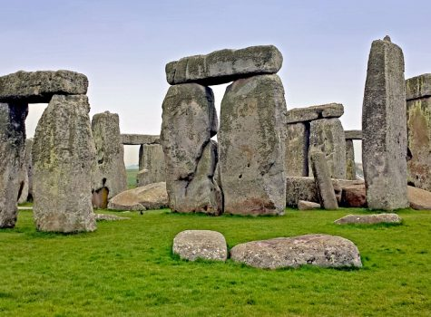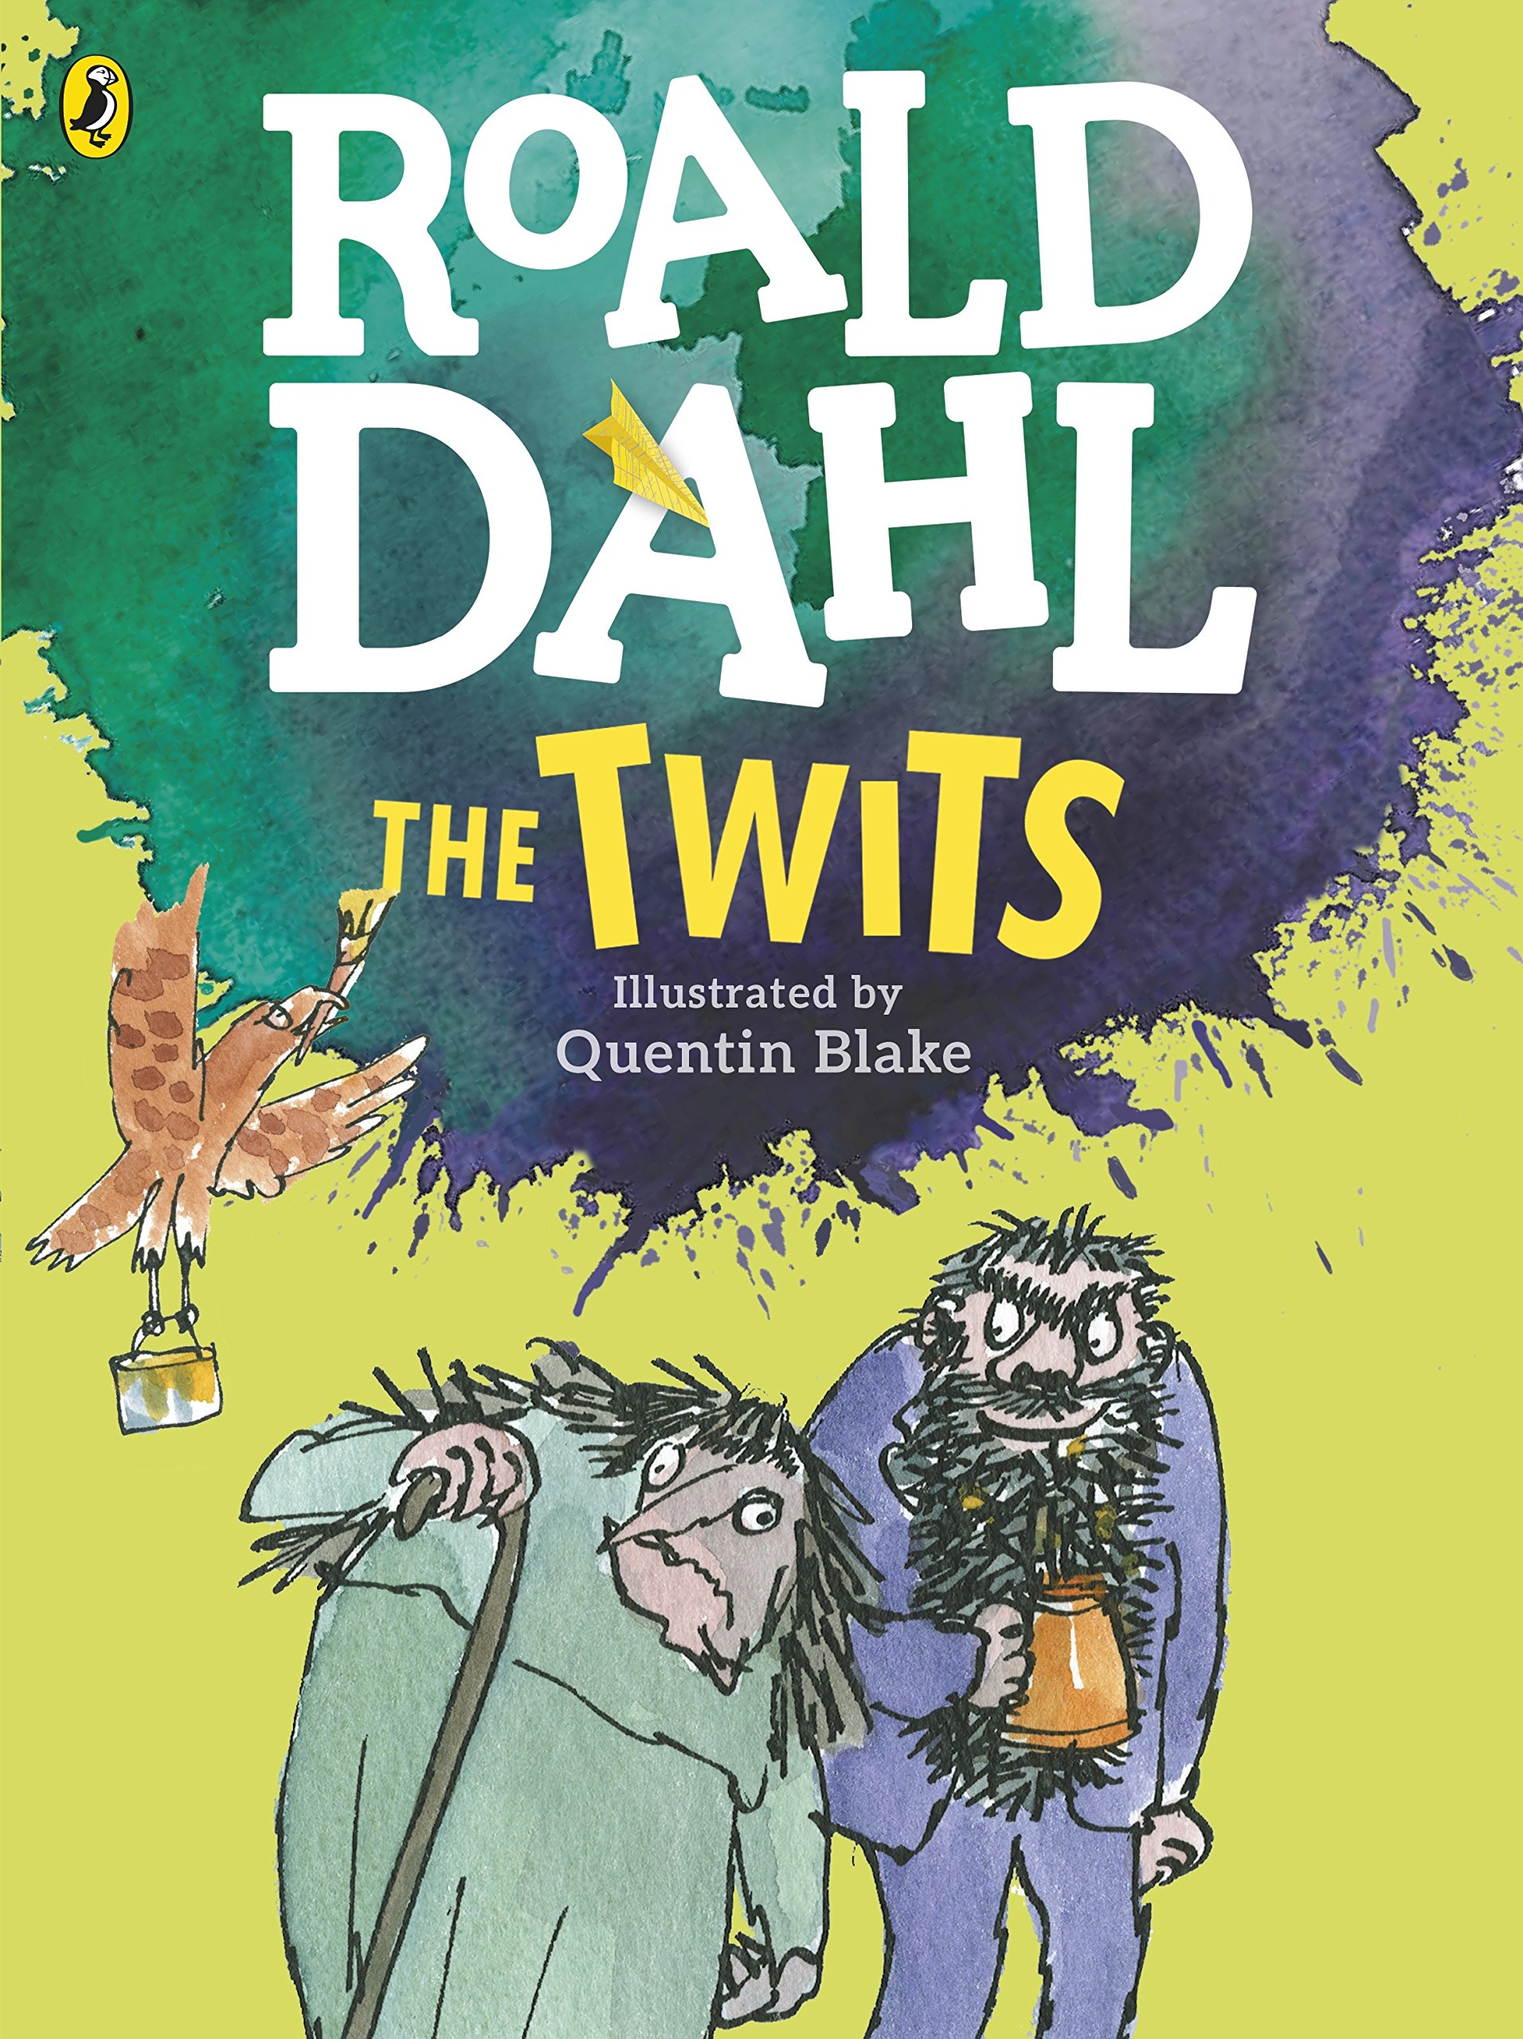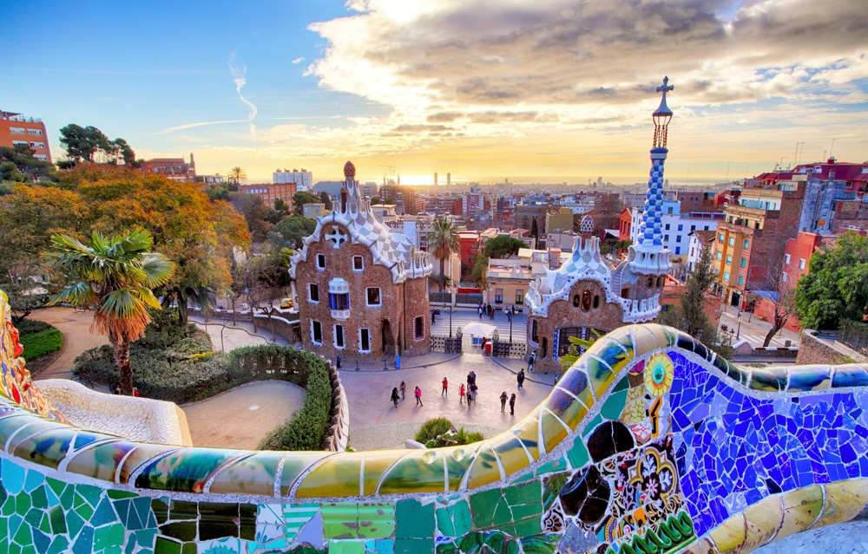 |  | PSHE & CITIZENSHIP:  - What can we do to stay safe?  - Feelings and relationships  GAMES  - Netball and football.  MUSIC  - Pattern and rhythm in music.  DT  - Spanish cooking  FRENCH  - Learning where in the world French is spoken.  - Learning personal details in French  - Writing/recording an introductory message to our new French partner class.
COMPUTING  - Internet Safety  - Algorithms - sequencing | HISTORY  Stone Age to the Iron Age  - When was the Stone Age? – timeline  - Stone Age life and changes such as farming  - What can we learn from historical sources (excavations) such as Skara Brae?  - Why was Stonehenge built?  - Changes to life in the Iron Age |  | GEOGRAPHY  Spain  - Use maps and atlases – countries and continents, Spanish locations  - Physical geography – mountains, climate zones  - Human geography – Catalonia, coastal development
SCIENCE  - Compare rocks based on physical properties and learn about fossils and soils.  - Investigate light and shadows. | ART  - Improving drawing and painting techniques using a range of materials.  - Ancient art –learning about art from this time and creating our own ‘cave’ paintings. |  | R.E.  - Creation and Fall – Christianity  - Angels - Christianity

