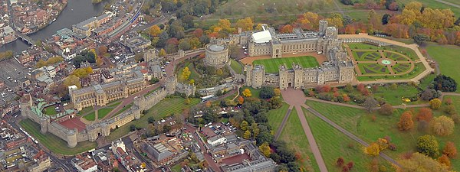

Year 2 visited Windsor Castle as part of their topic on Knights and Castles. Windsor Castle is the oldest and largest occupied castle in the world. It is open to visitors throughout the year.
Founded by William the Conqueror in the 11th century, it has since been the home of 39 monarchs.
The children have the chance to learn more about the life of a knight in a castle through a workshop:
They handle replica child-size armour and get close up to some fearsome weapons.
See where jousting tournaments actually took place.
Recreate the dubbing ceremony of a knight through role play.
Role play, using speaking and listening skills, training of a knight / members of the medieval Royal Court.
Dress up and use props for some role play activities.

The children’s view –
This trip was so much fun. I got to see the Queen’s things and go in her house.
It was a really good trip. I loved the marching soldiers and we got to copy them.
The talk was so interesting and we go to dress up in the clothes.
The best bit was getting close to all the things. I loved the shields. I liked the swords and weapons. We learnt so much.

