Vocabulary
Emperor/ Caesar | Emperors rule over an empire of countries conquered by their army. Roman emperors liked to give themselves the title Caesar.
Slave | The Romans often made people from the tribes they conquered into slaves. The slaves had to obey their masters and work hard, and could be bought and sold to other Romans.
Conquer/ invade | To take control of a country or tribe by force.
Britannia | The Roman name for Britain
Celts | Tribes who lived in southern Britain before the Romans came.
Centurion | A Roman army officer in charge of roughly 100 legionaries.
Legionary | A professional soldier in the Roman army.
Forum 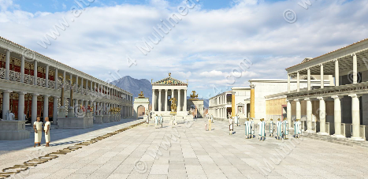 | A Roman town square were there were markets, but also where politicians gave speeches and where criminal trials were held.
Amphitheatre 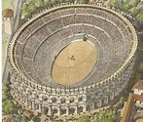 | A Roman open-air stadium which was oval in shape. A place where sporting events took place, including chariot races and gladiator fights.
Mosaic | A picture made up of lots of tiny tiles fitted together.
Villa.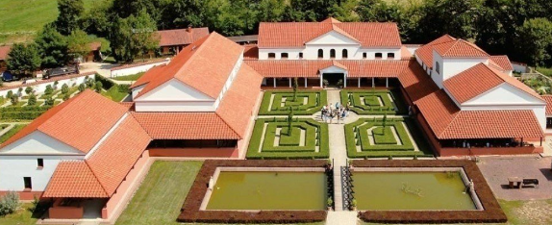 | A country house for rich Romans, usually surrounded by its own farmland.
Rampaging Romans
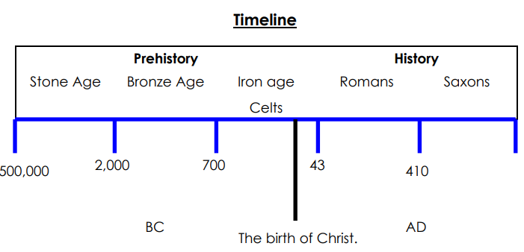
The Romans remained in Britain for almost 400 years. They brought many new ideas including towns and cities, and stone built houses. Life became very different from the Iron Age lifestyle of the Celtic tribes.
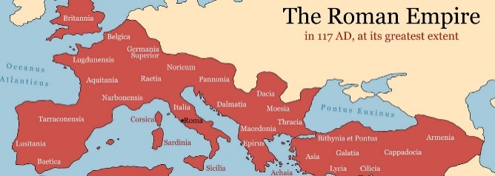
The Romans (who started in Rome, Italy) controlled a vast empire including Europe, modern day Turkey and parts of North Africa. England and Wales became part of that empire. Scotland wasn’t conquered. Their well-organised army was key to conquering new territories and keeping control. Having an empire made the Romans very rich.

Important People
Claudius  Claudius was the Roman emperor who successfully conquered Britain in AD43. | Julius Caesar  Julius Caesar was a Roman army general who became a very famous emperor. He helped the Roman empire grow. However, he failed to conquer Britain! | Boudicca  Boudicca was queen of the Iceni tribe of the Celts when the Romans invaded Britain. She led a rebellion against the Romans.
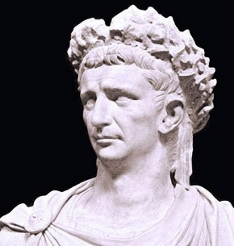 | 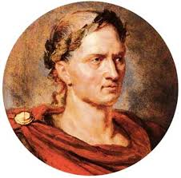 | 