Cool Canada?
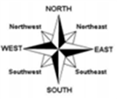
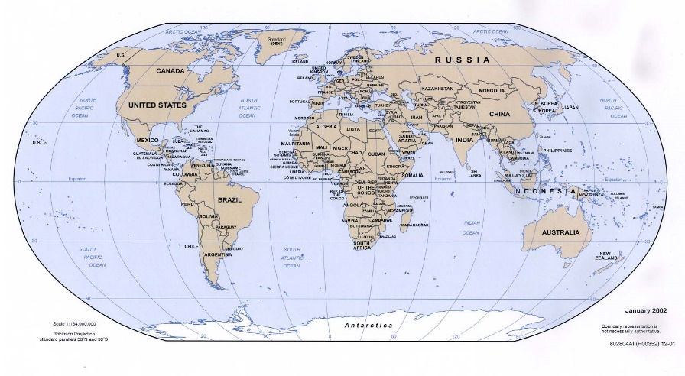
Location and Features
- Canada is part of the continent of North America, but it is separate country from the USA.
- It is in the Northern Hemisphere and is separated from Britain by the Atlantic Ocean.
- It is west of Britain and the northern parts of Canada are close to the Arctic Circle.
- It is roughly 40 times the size of Britain, but its population is only about half that of Britain.
- Its capital city is Ottowa and another well-known city is Toronto.
- The Canadian landscape includes many lakes, forests, mountains and waterfalls, including the famous Niagara Falls.
- The climate of Canada is colder than the UK in the Winter and hotter in the Summer.

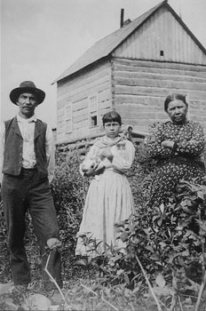
People of Canada
- Most people of modern Canada are of European descent – their ancestors emigrated from Europe (especially Britain and France) to live in Canada. This occurred mainly between 1815 and 1850, although some went before that.
- People in Canada speak English and French.
- There were people in Canada before the European settlers arrived, including the Inuit, who still live in the far North. Their traditional lifestyle was hunting for seals and caribou (reindeer) using spears, husky dogs and sledges. They lived in igloos when hunting and animal skin tents the rest of the time.
Vocabulary
Continent | One of the earth's seven major areas of land. The continents are Africa, Antarctica, Asia, Australia, Europe, North America, and South America.
Hemisphere | One half of the Earth. Geographers imagine the planet divided into 2 hemispheres, north and south of the equator.
Arctic Circle | This is an imaginary line drawn around the Earth. The area north of the Arctic Circle is called the Arctic – a very cold and icy place.
Climate | Climate is the average measurements of temperature, wind, humidity, snow, and rain in a place over the course of years. Climate is like the weather, but over a period long time.
emigrate | When people move permanently from one country to live in another.
igloo | A dome shaped building made from large blocks of ice.
caribou | Reindeer

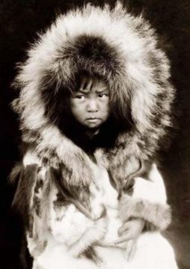
Modern Canada
- People in modern Canada live similar lifestyles to ours and the USA – including working in cities, farming and going to school.
- They enjoy similar pastimes, but also ice-hockey, ice-skating, skiing and American football.

