On the Move Topic Activities Year 2 Spring 2
Can you build a balloon rocket and launch it? | Make a paper aeroplane and fly it. Can you improve your design so that it flies for longer? Can you make it fly in a straight line? | Draw vehicles from pictures of real life. You could also research and use cartoon techniques that you find online. | Watch a video clip of a rocket launch and describe what happens in order.
Make a set of vehicle top trumps. You could include a rocket, car, horse-drawn cart, aeroplane, train, cruise ship, bike, dinghy… | 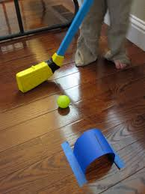  Have a go at re-inventing a popular sport. For example, you could try creating an indoor croquet game with a homemade stick…. | Make a ramp for a toy car to go down and time how long it takes. Can you make it travel down the same ramp faster? How about slower? Can you make it change direction partway down the ramp? | Can you create a fun, active trail for someone in your household to complete?
Create a marble run. What distance can you make your marble travel? Use careful measurement to find out. | 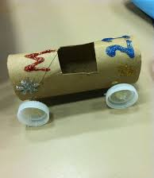  Can you create a homemade car with moving wheels, from things you find in your home? |  | Can you find out about the first:  - Aeroplane?  - Car?  - Train?  - Bike?

