By:___________________________________________________________
Andrews’ ENdowed Year 6
My ‘two paragraphs per day’ booklet – Week 1
Please make sure that you are looking at and using your success criteria (attached at the back of each day’s work) for each piece of writing to ensure you have everything you need inside each form of writing.
You are welcome to print this booklet off and write in it, or save it on our ‘Y6 curriculum’ google classroom and delete the lines and type it. The latter would be a better option so that I can see what you have been working on!
You are welcome to add a post on our curriculum google classroom in school time and I will try and give an answer. You are also welcome to write more than 2 paragraphs if you want to/ feel you can.
My ‘two paragraphs a day’ booklet
Write the opening to a story imagining you have just arrived here.
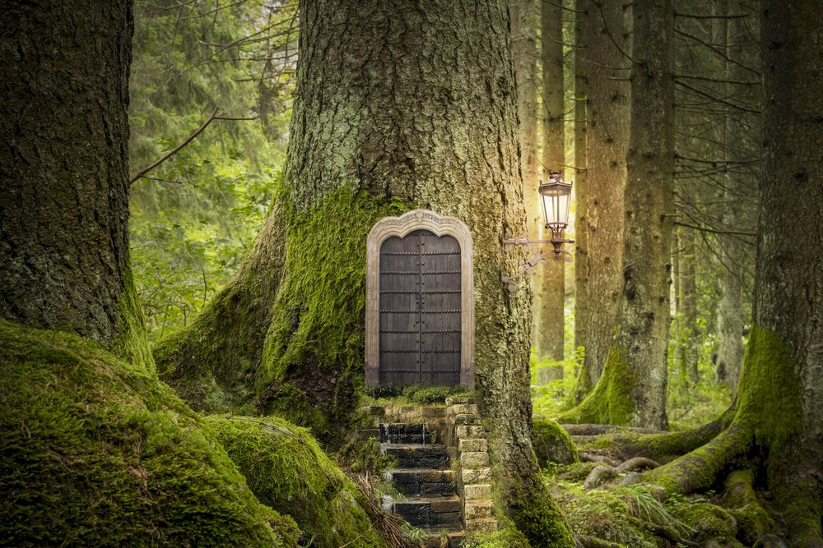
__________________________________________________________________________________________________________________________________________________________________________________________________________________________________________________________________________________________________________________________________________________________________________________________________________________________________________________________________________________________________________________________________________________________________________________________________________________________________________________________________________________________________________________________________________________________________________________________________________________________________________________________________________________________________________________________________________________________________________________________________________________________________________________________________________________________________________________________________________________________________________________________________________________________________________________________________________________________________________________________________________________________________________________________________________________________________________________________________________________________________________________________________________________________________________________________________________________________________________________________________________________________________________________________________________________________________________________________________________________________________________________________________________________________________________________________________________________________________________________________________________________________________________________________________________________________________________________________________

Success Criteria- Story openings
Objectives | Pupil/peer assessment | Teacher
I have caught the reader’s attention in my first sentence.
I have used wow words
The character reveals something about themselves
I have varied my sentence length-mixture of long and short sentences
My descriptions create imagery
I have used literary features
- Similes
- Metaphors
- Personification
- Alliteration
I have used paragraphs accurately
The audience learns where, when and who
I have stayed in the same tense throughout the opening
I have stayed in the same person throughout the opening- 1st, 2nd or 3rd.
I have held the readers attention throughout the opening
I used basic punctuation correctly including capital letters (full stops, commas, question and exclamation marks)
I have used complex punctuation correctly (brackets, hyphen, colon, semi-colon, apostrophe, speech marks)
I have included a promise of later action
Next time I will:
My ‘two paragraphs a day’ booklet
Write a diary from either the space man or a cave man.
____________________________________________________________________________________________________________________________________________________________________________________________________________________________________________________________________________________________________________________________________________________________________________________________________________________________________________________________________________________________________________________________________________________________________________________________________________________________________________________________________________________________________________________________________________________________________________________________________________________________________________________________________________________________________________________________________________________________________________________________________________________________________________________________________________________________________________________________________________________________________________________________________________________________________________________________________________________________________________________________________________________________________________________________________________________________________________________________________________________________________________________________________________________________________________________________________________________________________________________________________________________________________________________________________________________________________________________________________________________________________________________________________________________________________________________________________________________________________________________________________________________________________________________________________________________________________________________________________________________________________________________

Success Criteria- Diary
Objectives | Pupil/peer assessment | Teacher
I have written the date of the diary entry
I have started appropriately eg. Dear Diary etc.
I have used time connectives eg. Next, after, meanwhile etc
I have included illustrations (if helpful)
I have used the past tense
I have explained my true feelings
I have varied my sentence length- used both long and short sentences
I have showed chronological order(time order)
I have used 1st person
I have included details and description to help the reader understand what has happened
I have used rhetorical questions
I have used colloquial language eg. Slang, nicknames
I used basic punctuation correctly including capital letters (full stops, commas, question and exclamation marks)
I have used complex punctuation correctly (brackets, hyphen, colon, semi-colon, apostrophe, speech marks)
I have used wow words
I have ended in the appropriate way
Next time I will:
My ‘two paragraphs a day’ booklet
Write a non-chronological report of how you feel being the lost keychain monkey.
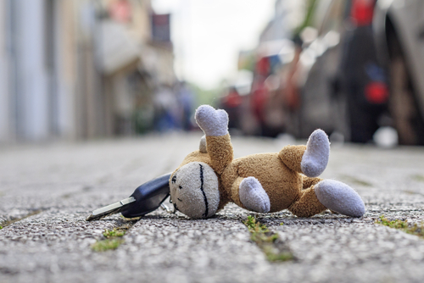
__________________________________________________________________________________________________________________________________________________________________________________________________________________________________________________________________________________________________________________________________________________________________________________________________________________________________________________________________________________________________________________________________________________________________________________________________________________________________________________________________________________________________________________________________________________________________________________________________________________________________________________________________________________________________________________________________________________________________________________________________________________________________________________________________________________________________________________________________________________________________________________________________________________________________________________________________________________________________________________________________________________________________________________________________________________________________________________________________________________________________________________________________________________________________________________________________________________________________________________________________________________________________________________________________________________________________________________________________________________________________________________________________________________________________________________________________________________________________________________________________________________________________________________________________________________________________________________________________

Success Criteria - Non- chronological reports
Objectives | Pupil/peer assessment | Teacher
My report gives the reader factual information about a specific topic
I have used a title, which tells the reader what the report is about.
I have used an introduction which tells the reader a little bit of information about the subject (don’t go into lots of detail yet)
I have used paragraphs-each one describes a main point that you want to tell the reader.
I have written in a non-chronological order (does not have to be in time order)
I have written in the present tense
I have used correct technical vocabulary
I have varied my sentence length-used both long and short sentences.
I used basic punctuation correctly including capital letters (full stops, commas, question and exclamation marks)
I have used complex punctuation correctly (brackets, hyphen, colon, semi-colon, apostrophe, speech marks)
I have included subheadings
I have used quotation marks correctly and acknowledged the source
I have ended with a conclusion
Next time I will:

My ‘two paragraphs a day’ booklet
Write an alternative ending to Jack and the beanstalk.
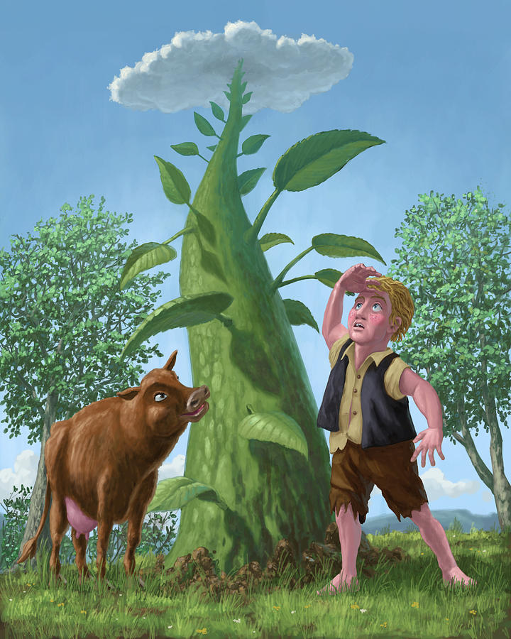
____________________________________________________________________________________________________________________________________________________________________________________________________________________________________________________________________________________________________________________________________________________________________________________________________________________________________________________________________________________________________________________________________________________________________________________________________________________________________________________________________________________________________________________________________________________________________________________________________________________________________________________________________________________________________________________________________________________________________________________________________________________________________________________________________________________________________________________________________________________________________________________________________________________________________________________________________________________________________________________________________________________________________________________________________________________________________________________________________________________________________________________________________________________________________________________________________________________________________________________________________________________________________________________________________________________________________________________________________________________________________________________________________________________________________________________________________________________________________________________________________________________________________________________________________________________________________________________________________________________________________________________

Success Criteria- Narrative planning – Alternative ending
Objectives | Pupil/peer assessment | Teacher
I have decided my genre and included the appropriate elements
I have varied the length of my sentences
Description of the setting and characters are developed throughout the whole story
My characters are believable.
I have planned my opening-it grabs the readers attention
I have described details using the 5 senses
I have planned my build up
I have a problem/s and they are resolved or left on a cliff-hanger
I have planned my resolution/cliff-hanger etc
I have used wow words
I have written in paragraphs
I have included dialogue between 2 characters which develops the story
My ending is interesting- NOT “they all went home” or “it was a dream”
I used basic punctuation correctly including capital letters (full stops, commas, question and exclamation marks)
I have used complex punctuation correctly (brackets, hyphen, colon, semi-colon, apostrophe, speech marks)
Next time I will:

My ‘two paragraphs a day’ booklet
Write a recount of this day, as if you were one of the baby mushrooms that have grown up into adults.
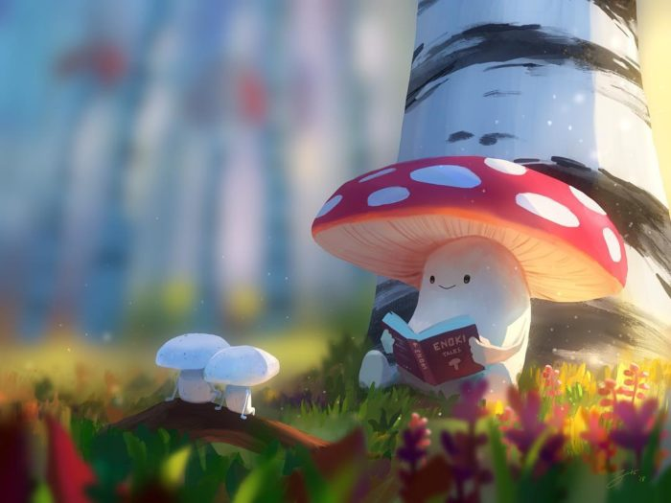
____________________________________________________________________________________________________________________________________________________________________________________________________________________________________________________________________________________________________________________________________________________________________________________________________________________________________________________________________________________________________________________________________________________________________________________________________________________________________________________________________________________________________________________________________________________________________________________________________________________________________________________________________________________________________________________________________________________________________________________________________________________________________________________________________________________________________________________________________________________________________________________________________________________________________________________________________________________________________________________________________________________________________________________________________________________________________________________________________________________________________________________________________________________________________________________________________________________________________________________________________________________________________________________________________________________________________________________________________________________________________________________________________________________________________________________________________________________________________________________________________________________________________________________________________________________________________________________________________________________________________________________

Success Criteria- Recount (not a diary)
Objectives | Pupil/peer assessment | Teacher
I have used an introduction which gives the who, when and where of the event
I have used time connectives eg. Next, after, meanwhile etc
I have included illustrations (if helpful)
I have used the past tense
I have used wow words
I have varied my sentence length- used both long and short sentences
I have showed chronological order(time order)
I used time connectives eg. First, next, after
I have used 1st or 3rd person eg. I or he, she, they.
I have included details and description to help the reader understand what has happened
I used basic punctuation correctly including capital letters (full stops, commas, question and exclamation marks)
I have used complex punctuation correctly (brackets, hyphen, colon, semi-colon, apostrophe, speech marks)
My closing statement rounds off the recount appropriately
My layout is neat and clear
Next time I will:

