The Mayans

|  |  |
| --- | --- |
| Vocabulary | |
| Civilisation | An organised society with its own  culture and way of life, existing in  a particular area over a particular  period of time. |
| Ritual | A ceremony, often religious, with set actions performed in a set order. |
| Scribe | People paid to write things down,  either as an official record or for  someone else unable to write. |
| Codices | Ancient handwritten texts. Maya  codices could be unfolded like a  concertina. One text is called a codex. |
| Cacao beans | Cacao trees sprout pods directly from their trunks. When they are ripe, the pods can be broken open to reveal the beans, which can then be dried, roasted and ground. |
| Dynasty | A series of rulers or leaders who are all from the same family, or a period when a  country is ruled by them. |
| Sacrifice | The act of surrendering  a possession, as an  offering to a deity |

Year 5 History Knowledge Organiser

At a glance:

The Maya are native Americans of Central America, who built a great civilisation in the tropical rainforest that lasted for over 2000 years. The earliest Maya settlements were built in about 1800 BCE. The golden age of the Maya was between 250 and 900 CE

**Cause and Consequence:**

At its peak, the Mayan civilisation was made up of 40 great cities and almost 2 million people. Suddenly, in around 900, many of these significant Maya settlements were **abandoned.** No one is quite sure why, but it is possible that changes in the climate or overpopulation made the cities uninhabitable. The Maya still live in

the same areas of Central America today, continuing many of the **traditions.**



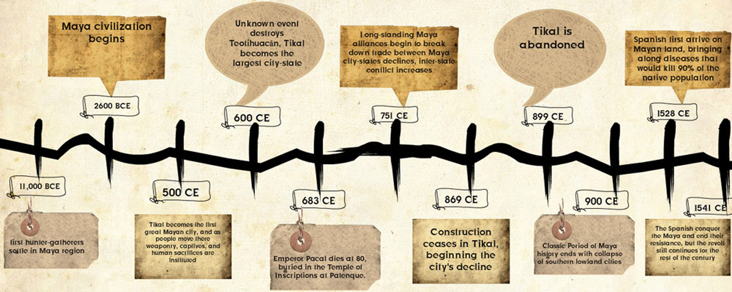 Temple of the Serpent, Chitchen Itza, Mexico

Webite: <https://maya.lgfl.org.uk/>

Mayan Glyphs

