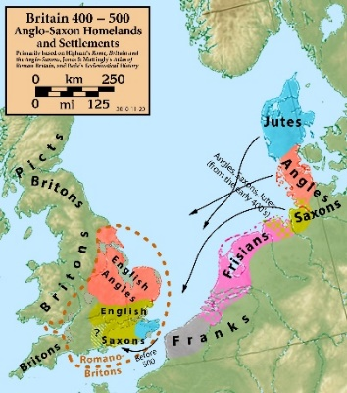
How do we determine the ideals that should be honoured in a model society?
The Saxon incomers arrived on the coasts or used rivers to get inland to find suitable spots to settle. They built their earliest settlements close to these rivers or the coast. This gave them a ready made transport route for bringing in more people and goods or trading with other people and, particularly at first, maintaining contact with their former homelands.

As Christianity was gradually re-introduced in Saxon areas, Christian churches were built. Most churches were built of wood, but later stone churches replaced some of these. Often these would be the only stone-built buildings in a given location.

Earliest kingdom:
Deira – Angle kingdom. First confirmed King was Aelli (this kingdom later became part of the much larger kingdom of Northumbria)
Kingdoms by 600
Later kingdoms: (no information available about when each developed)
Kent - Angle kingdom. First king – Hengist, most important king Ethelred (d 616).
Essex - East Saxon kingdom – important King Saebert.
East Anglia – Angle kingdom. Important kings Redwald (probable subject of Sutton Hoo burial)
Bernicia - Angle kingdom (this kingdom also became part of Northumbria)
Later developments: (again no information about when each developed)
Mercia – Angle kingdom. Important kings, Ethelbald, Offa (Offa’s Dyke) and Penda.
Wessex – West Saxons kingdom. First king – Cerdic, important kings Egbert, Alfred, Athelstan, Edward the Confessor. Full list of Kings of Wessex.
Northumbria – most important kings - Edwin, Oswald (both killed by Penda of Mercia) and Oswy

Anglo Saxons

Vocabulary
Anglo-Saxons | Name given to a variety of different tribes who invaded Britain from mainland Europe following the retreat of the Romans.
Bayeux Tapestry | Embroidery showing the story of the Norman Conquest, and defeat of the Anglo-Saxons by William the Conqueror
Beowulf | England before the Norman Conquest. More than 3,000 lines long, Beowulf relates the exploits of its eponymous hero, and his successive battles with a monster named Grendel, with Grendel’s revengeful mother, and with a dragon which was guarding a hoard of treasure.
Frige | Queen of the pagan gods, protected the home, marriages and pregnant women. Friday is named after her.
Hastings | Location of a battle where the invading Normans defeated King Harold Godwinson.
Paganism | Multi-god religion practised in Northern Europe. Later replaced by Christianity.
Runes | The alphabet that was used by the Anglo-Saxons to write.
Shield -wall | Defensive formation used in battle, where warriors shields overlap for protection.
Sutton Hoo | Archaeological excavation of an Anglo-Saxon burial site in Suffolk.
Taefl | Popular battle board game played by the Anglo-Saxons. Vikings and Celts.
Woden | One-eyed king of the pagan gods known for his wisdom. Wednesday is named after him.
